17.83: Both the volume of the cup and the volume of the olive oil increase when the temperature increases, but is larger for the oil so it expands more. When the oil starts to overflow,
is the cross-sectional area of the cup.
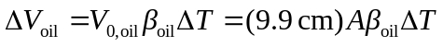
The area A divides out. Solving for 